Lab Number: 1
Title: Implementing Process Scheduling Algorithms

Objective:
To implement and compare different CPU scheduling algorithms like FCFS, SJF, SRTN, RR, and Preemptive Priority and to analyze their performance based on waiting time, turnaround time, and completion time.

Programming Language: C

IDE: DEV C++

Theory:
CPU scheduling is the mechanism by which an operating system decides which of the ready, waiting processes in the ready queue is allocated the CPU next. Since the CPU can execute only one process at a time, an efficient scheduling policy is essential to maximize CPU utilization, throughput, and fairness while minimizing waiting time, turnaround time, and response time. Scheduling algorithms are broadly classified as non-preemptive, where a running process keeps the CPU until it finishes or voluntarily gives it up, and preemptive, where a running process can be interrupted and moved back to the ready queue if a higher-priority or shorter process arrives.
First Come First Serve (FCFS) is the simplest non-preemptive algorithm; processes are executed strictly in the order they arrive, which is easy to implement but can cause long waiting times for short processes stuck behind long ones (the convoy effect).
Shortest Job First (SJF), Non-Preemptive selects the process with the smallest burst time to run next once the CPU is free, minimizing average waiting time but risking starvation of longer processes.
Shortest Remaining Time Next (SRTN) is the preemptive version of SJF; at every time unit the scheduler picks the process with the smallest remaining burst time, preempting the current process if a shorter one becomes eligible to run.
Round Robin (RR) assigns each process a fixed time slice, called a time quantum. Processes are executed in cyclic order; a process that does not finish within its quantum is preempted and placed at the back of the ready queue, giving every process a fair share of the CPU.
Preemptive Priority Scheduling assigns a priority value to each process (a lower number conventionally means higher priority) and, at every time unit, runs the process with the highest priority among those remaining; a running process is preempted immediately if a higher-priority process becomes eligible.
Question 1.) Perform First Come First Serve (FCFS) Scheduling Algorithm.

Algorithm:
- Start.
- Read the number of processes n, and for each process read its Process ID, Arrival Time, and Burst Time.
- Sort all processes in ascending order of their Arrival Time.
- Initialize current time = 0.
- For each process in sorted order: if the CPU is idle (current time < arrival time), advance current time to arrival time.
- Set Start Time = current time.
- Set Finish Time = Start Time + Burst Time; advance current time to Finish Time.
- Calculate Turnaround Time = Finish Time − Arrival Time.
- Calculate Waiting Time = Turnaround Time − Burst Time.
- Repeat steps 5–9 for all processes.
- Compute and display Average Waiting Time and Average Turnaround Time.
- Stop.

Source Code:
#include <stdio.h>

struct Process {
int pid, arrival, burst, start, finish, waiting, turnaround;
};

void sortByArrival(struct Process p[], int n) {
for (int i = 0; i < n-1; i++) {
int min = i;
for (int j = i+1; j < n; j++)
if (p[j].arrival < p[min].arrival) min = j;
struct Process t = p[min]; p[min] = p[i]; p[i] = t;
}
}

void fcfs(struct Process p[], int n) {
sortByArrival(p, n);
int time = 0;
for (int i = 0; i < n; i++) {
if (time < p[i].arrival) time = p[i].arrival;
p[i].start = time;
p[i].finish = time + p[i].burst;
p[i].turnaround = p[i].finish - p[i].arrival;
p[i].waiting = p[i].turnaround - p[i].burst;
time = p[i].finish;
}
}

int main() {
int n;
printf("Enter number of processes: "); scanf("%d", &n);
struct Process p[n];
for (int i = 0; i < n; i++) {
p[i].pid = i+1;
printf("Arrival Time: "); scanf("%d", &p[i].arrival);
printf("Burst Time : "); scanf("%d", &p[i].burst);
}
fcfs(p, n);
float wt = 0, tat = 0;
printf("\nPID Arrival Burst Start Finish Wait TAT\n");
for (int i = 0; i < n; i++) {
printf("%-4d %-8d %-6d %-6d %-7d %-5d %d\n",
p[i].pid, p[i].arrival, p[i].burst,
p[i].start, p[i].finish, p[i].waiting, p[i].turnaround);
wt += p[i].waiting; tat += p[i].turnaround;
}
printf("Avg Waiting Time: %.2f\n", wt/n);
printf("Avg Turnaround : %.2f\n", tat/n);
return 0;
}

Question 2.) Perform Preemptive Priority Scheduling Algorithm.

Algorithm:
- Start.
- Read the number of processes n, and for each process read its PID, Arrival Time, Burst Time, and Priority (lower number = higher priority).
- Initialize remaining time for each process = burst time. Set current time = 0, completed = 0.
- While completed < n: scan all processes with arrival time ≤ current time and remaining time > 0.
- Select the process with the lowest priority number (highest priority). Break ties by earliest arrival time.
- If no process is available, advance current time by 1 (CPU idle).
- Otherwise, execute the selected process for 1 time unit; decrement its remaining time.
- If remaining time becomes 0: set Finish Time = current time; compute Turnaround Time and Waiting Time; increment completed.
- Increment current time; repeat from step 4.
- Display results and averages. Stop.

Source Code:
#include <stdio.h>
#include <limits.h>

struct Process {
int pid, arrival, burst, priority, remaining, finish, waiting, turnaround;
};

void preemptivePriority(struct Process p[], int n) {
for (int i = 0; i < n; i++) p[i].remaining = p[i].burst;
int completed = 0, time = 0;
while (completed < n) {
int idx = -1, best = INT_MAX;
for (int i = 0; i < n; i++)
if (p[i].arrival <= time && p[i].remaining > 0)
if (p[i].priority < best ||
(p[i].priority == best && p[i].arrival < p[idx].arrival))
{ best = p[i].priority; idx = i; }
if (idx == -1) { time++; continue; }
p[idx].remaining--;
time++;

if (p[idx].remaining == 0) {
completed++;
p[idx].finish = time;
p[idx].turnaround = p[idx].finish - p[idx].arrival;
p[idx].waiting = p[idx].turnaround - p[idx].burst;
}
}
}

int main() {
int n;
printf("Enter number of processes: "); scanf("%d", &n);
struct Process p[n];
for (int i = 0; i < n; i++) {
p[i].pid = i+1;
printf("Arrival: "); scanf("%d", &p[i].arrival);
printf("Burst : "); scanf("%d", &p[i].burst);
printf("Priority: "); scanf("%d", &p[i].priority);
}
preemptivePriority(p, n);
float wt = 0, tat = 0;
printf("\nPID Arrival Burst Priority Finish Wait TAT\n");
for (int i = 0; i < n; i++) {
printf("%-4d %-8d %-6d %-9d %-7d %-5d %d\n",
p[i].pid, p[i].arrival, p[i].burst, p[i].priority,
p[i].finish, p[i].waiting, p[i].turnaround);
wt += p[i].waiting; tat += p[i].turnaround;
}
printf("Avg Waiting Time: %.2f\n", wt/n);
printf("Avg Turnaround : %.2f\n", tat/n);
return 0;
}

Question 3.) Perform Shortest Job Next (SJN) Non-Preemptive Scheduling Algorithm.

Algorithm:
- Start.
- Read the number of processes n, and for each process read its PID, Arrival Time, and Burst Time.
- Initialize current time = 0, completed = 0, done[] = false for all processes.
- While completed < n: from all processes with arrival ≤ current time and not done, select the one with minimum burst time (tie-break: earliest arrival).
- If no such process exists, advance current time to the next smallest arrival time.
- Otherwise, set Start Time = current time; run the process to completion (non-preemptive).
- Set Finish Time = Start Time + Burst Time; advance current time = Finish Time.
- Compute Turnaround Time = Finish − Arrival; Waiting Time = Turnaround − Burst.
- Mark process as done; increment completed. Repeat from step 4.
- Display results and averages. Stop.

Source Code:
#include <stdio.h>
#include <limits.h>

struct Process {
int pid, arrival, burst, start, finish, waiting, turnaround, done;
};

void sjn(struct Process p[], int n) {
int completed = 0, time = 0;
for (int i = 0; i < n; i++) p[i].done = 0;
while (completed < n) {
int idx = -1, minB = INT_MAX;
for (int i = 0; i < n; i++)
if (!p[i].done && p[i].arrival <= time)
if (p[i].burst < minB ||
(p[i].burst == minB && p[i].arrival < p[idx].arrival))
{ minB = p[i].burst; idx = i; }
if (idx == -1) {
int next = INT_MAX;
for (int i=0;i<n;i++) if(!p[i].done && p[i].arrival<next) next=p[i].arrival;
time = next; continue;
}
p[idx].start = time;
p[idx].finish = time + p[idx].burst;
p[idx].turnaround = p[idx].finish - p[idx].arrival;
p[idx].waiting = p[idx].turnaround - p[idx].burst;
p[idx].done = 1; time = p[idx].finish; completed++;
}
}

int main() {
int n;
printf("Enter number of processes: "); scanf("%d", &n);
struct Process p[n];
for (int i = 0; i < n; i++) {
p[i].pid = i+1;
printf("Arrival: "); scanf("%d", &p[i].arrival);
printf("Burst : "); scanf("%d", &p[i].burst);
}
sjn(p, n);
float wt = 0, tat = 0;
printf("\nPID Arrival Burst Start Finish Wait TAT\n");
for (int i = 0; i < n; i++) {
printf("%-4d %-8d %-6d %-6d %-7d %-5d %d\n",
p[i].pid,p[i].arrival,p[i].burst,
p[i].start,p[i].finish,p[i].waiting,p[i].turnaround);
wt += p[i].waiting; tat += p[i].turnaround;
}
printf("Avg Waiting Time: %.2f\n", wt/n);
printf("Avg Turnaround : %.2f\n", tat/n);
return 0;
}

Question 4.) Perform Shortest Remaining Time Next (SRTN) Preemptive Scheduling Algorithm.

Algorithm:
- Start.
- Read the number of processes n, and for each process read its PID, Arrival Time, and Burst Time.
- Initialize remaining time = burst time for each process. Set current time = 0, completed = 0.
- While completed < n: scan all arrived processes with remaining time > 0; select the one with minimum remaining time (tie-break: earliest arrival).
- If no process is available, advance current time to the next arrival.
- Execute the selected process for 1 unit of time; decrement remaining time.
- If remaining time becomes 0: record Finish Time = current time; compute Turnaround Time and Waiting Time; increment completed.
- Increment current time; repeat from step 4.
- Display results and averages. Stop.

Source Code:
#include <stdio.h>
#include <limits.h>

struct Process {
int pid, arrival, burst, remaining, finish, waiting, turnaround;
};

void srtn(struct Process p[], int n) {
for (int i = 0; i < n; i++) p[i].remaining = p[i].burst;
int completed = 0, time = 0;
while (completed < n) {
int idx = -1, minR = INT_MAX;
for (int i = 0; i < n; i++)
if (p[i].arrival <= time && p[i].remaining > 0)
if (p[i].remaining < minR ||
(p[i].remaining == minR && p[i].arrival < p[idx].arrival))
{ minR = p[i].remaining; idx = i; }
if (idx == -1) {
int next = INT_MAX;
for(int i=0;i<n;i++) if(p[i].remaining>0 && p[i].arrival<next) next=p[i].arrival;
time = next; continue;
}
p[idx].remaining--; time++;
if (p[idx].remaining == 0) {
completed++;
p[idx].finish = time;
p[idx].turnaround = p[idx].finish - p[idx].arrival;
p[idx].waiting = p[idx].turnaround - p[idx].burst;
}
}
}

int main() {
int n;
printf("Enter number of processes: "); scanf("%d", &n);
struct Process p[n];
for (int i = 0; i < n; i++) {
p[i].pid = i+1;
printf("Arrival: "); scanf("%d", &p[i].arrival);
printf("Burst : "); scanf("%d", &p[i].burst);
}
srtn(p, n);
float wt = 0, tat = 0;
printf("\nPID Arrival Burst Finish Wait TAT\n");
for (int i = 0; i < n; i++) {
printf("%-4d %-8d %-6d %-7d %-5d %d\n",
p[i].pid, p[i].arrival, p[i].burst,
p[i].finish, p[i].waiting, p[i].turnaround);
wt += p[i].waiting; tat += p[i].turnaround;
}
printf("Avg Waiting Time: %.2f\n", wt/n);
printf("Avg Turnaround : %.2f\n", tat/n);
return 0;
}

Question 5.) Perform Round Robin (RR) Scheduling Algorithm.

Algorithm:
- Start.
- Read n processes (PID, Arrival Time, Burst Time) and the time quantum q.
- Sort processes by arrival time. Initialize remaining time = burst time for all processes. Set current time = 0.
- Enqueue all processes that have arrived by time 0 into a ready queue.
- Dequeue the front process. Execute it for min(q, remaining time) units.
- Advance current time by the executed units. Enqueue any newly arrived processes.
- If the process is finished: record Finish Time, compute Turnaround Time and Waiting Time. Otherwise re-enqueue it at the rear.
- If the queue is empty but processes remain, advance time to the next arrival and enqueue it.
- Repeat steps 5–8 until all processes are complete.
- Display results and averages. Stop.

Source Code:
#include <stdio.h>
#define MAX 100

struct Process {
int pid, arrival, burst, remaining, finish, waiting, turnaround, inQueue;
};

int queue[MAX*100], front = 0, rear = 0;
void enqueue(int v) { queue[rear++] = v; }
int dequeue() { return queue[front++]; }
int isEmpty() { return front == rear; }

void roundRobin(struct Process p[], int n, int q) {
for (int i = 0; i < n; i++) { p[i].remaining = p[i].burst; p[i].inQueue = 0; }
// sort by arrival
for (int i=0;i<n-1;i++) for(int j=i+1;j<n;j++)
if(p[j].arrival<p[i].arrival){struct Process t=p[i];p[i]=p[j];p[j]=t;}
int time = 0, completed = 0;
for (int i=0;i<n;i++) if(p[i].arrival<=time){enqueue(i);p[i].inQueue=1;}
while (completed < n) {
if (isEmpty()) {
int next = 99999;
for(int i=0;i<n;i++) if(!p[i].inQueue&&p[i].remaining>0&&p[i].arrival<next) next=p[i].arrival;
time = next;
for(int i=0;i<n;i++) if(!p[i].inQueue&&p[i].remaining>0&&p[i].arrival<=time){enqueue(i);p[i].inQueue=1;}
continue;
}
int idx = dequeue();
int exec = (p[idx].remaining < q) ? p[idx].remaining : q;
p[idx].remaining -= exec; time += exec;
for(int i=0;i<n;i++) if(!p[i].inQueue&&p[i].remaining>0&&p[i].arrival<=time){enqueue(i);p[i].inQueue=1;}
if (p[idx].remaining == 0) {
completed++;
p[idx].finish = time;
p[idx].turnaround = p[idx].finish - p[idx].arrival;
p[idx].waiting = p[idx].turnaround - p[idx].burst;
} else { enqueue(idx); }
}
}

int main() {
int n, q;
printf("Processes: "); scanf("%d", &n);
struct Process p[n];
for(int i=0;i<n;i++){
p[i].pid=i+1;
printf("Arrival: "); scanf("%d",&p[i].arrival);
printf("Burst : "); scanf("%d",&p[i].burst);
}
printf("Time Quantum: "); scanf("%d",&q);
roundRobin(p, n, q);
float wt=0, tat=0;
printf("\nPID Arrival Burst Finish Wait TAT\n");
for(int i=0;i<n;i++){
printf("%-4d %-8d %-6d %-7d %-5d %d\n",
p[i].pid,p[i].arrival,p[i].burst,
p[i].finish,p[i].waiting,p[i].turnaround);
wt+=p[i].waiting; tat+=p[i].turnaround;
}
printf("Avg Waiting Time: %.2f\n", wt/n);
printf("Avg Turnaround : %.2f\n", tat/n);
return 0;
}

Output Section:

Q.1 Output (FCFS):
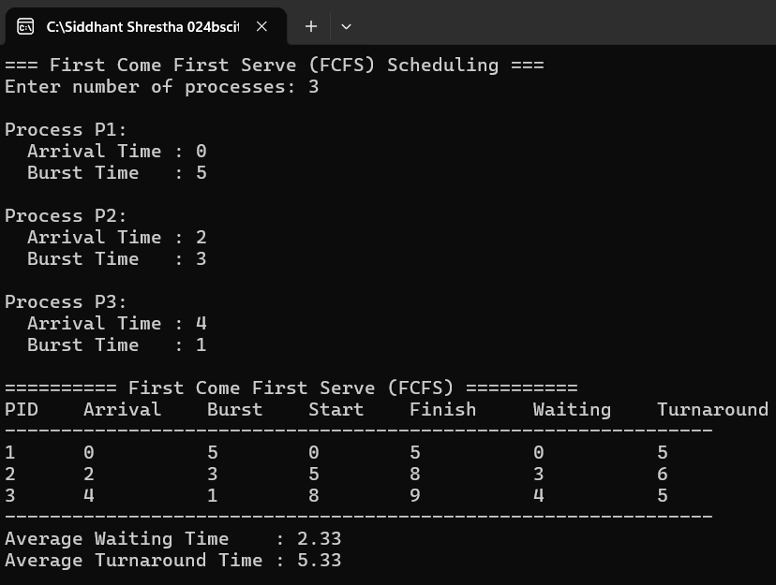

Q.2 Output (Preemptive Priority):
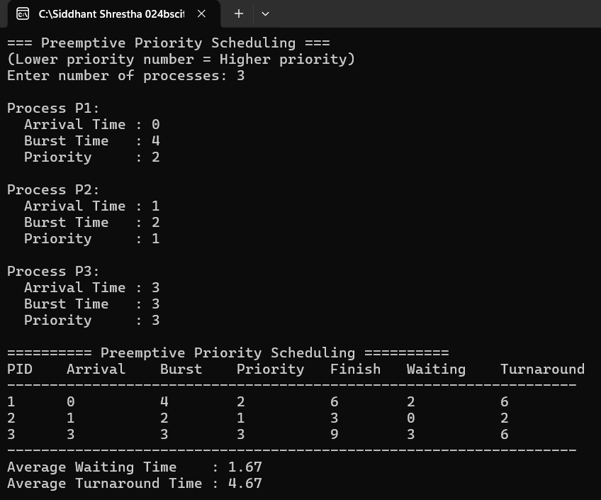

Q.3 Output (SJN Non-Preemptive):
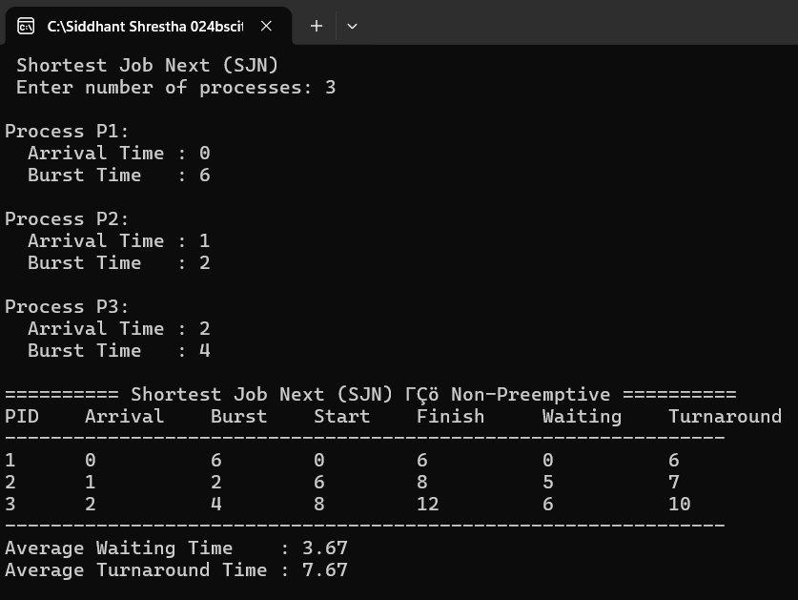
Q.4 Output (SRTN):
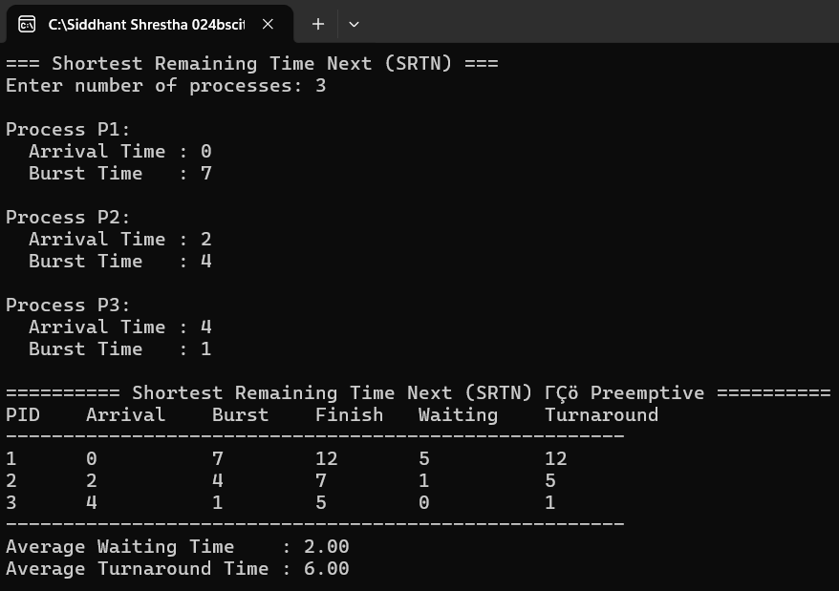

Q.5 Output (Round Robin, Quantum = 2):
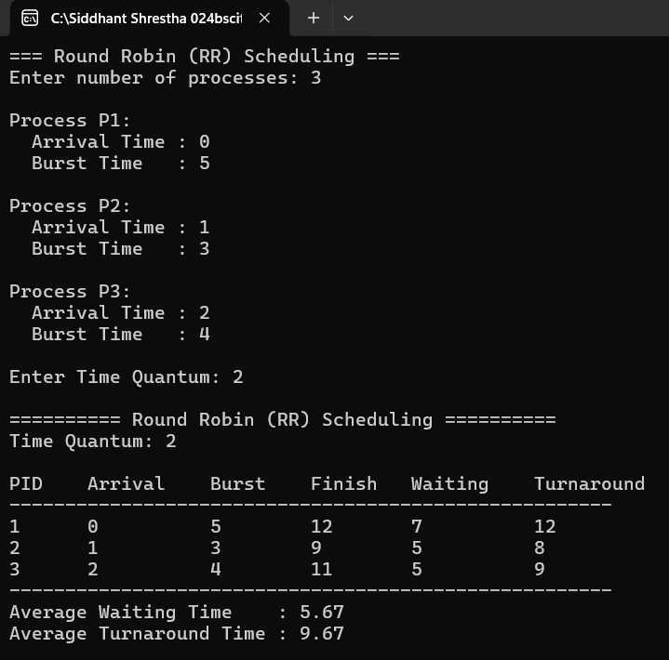
Discussion:
FCFS was simple but suffered from the convoy effect, increasing average waiting time. SJF improved this by prioritizing shorter jobs, and SRTN improved it further by allowing preemption when shorter processes arrived. Round Robin ensured fairness through fixed time quantums but was sensitive to quantum size, too small, caused overhead, too large made it act like FCFS. Preemptive Priority Scheduling handled urgent tasks well but risked starving low-priority processes without aging.

Conclusion:
Hence, we successfully implemented and analyzed five major process scheduling algorithms, First Come First Serve (FCFS), Preemptive Priority, Shortest Job Next (SJN), Shortest Remaining Time Next (SRTN), and Round Robin (RR) using the C programming language in VS Code as the IDE. Through this lab, we gained practical familiarity with CPU scheduling concepts, understood the trade-offs between simplicity, fairness, and efficiency, and observed how different algorithms affect average waiting time and turnaround time. SRTN proved optimal in terms of average waiting time, while Round Robin provided the fairest CPU allocation among all methods studied.

